Realising Savings on Course Fees via Learner Loans

Preamble
For loan-fundable courses, the loan fee is usually lower than the full-cost fee, and most people hastily assume the former to be cheaper. This cost differential is more apparent than real since the loan option has a “hidden” interest component attached to it. There is however a way in which one can realize the potential saving that the loan option affords—it requires some action on the part of the loan recipient. The following notes explain.
The Saving Scheme
- The Student Loans Company (SLC) publishes a ‘Drawdown Calendar’ for each academic year (see page 2). The said Calendar gives the dates on which course fee instalments are paid to colleges on behalf of loan learners—a process which (a) creates a partial loan liability (i.e., debt) on a learner’s account, and (b) initiates the calculation of interest charges on the said liability.
- Course fee instalments are normally paid on the 3rd Wednesday of each month (i.e., on the dates highlighted in green on the Calendar). Occasionally, the start date of a course may be such that ‘the 3rd Wednesday’ for that month is within the two-week pre-liability “grace period” granted to loan learners. In that case, the course fee instalment for the first month is rolled over and paid together with that for the following month.
- The amount of interest that one pays depends on how long the partial loan liabilities created each month remain on one’s loan account. Therefore, if one were to pay off the said liabilities as they occur (or at the earliest possible opportunity), the interest charge accrued would be negligible.
- Because one is allowed to make voluntary loan repayments at any time over the loan period, one can realise substantial savings of up to 20% of the loan fee by setting up a system that pays off—in a timely and consistent manner—the monthly liabilities on one’s loan account for the entire duration of the course. But please note: It would be irrational to use a credit card for this purpose because one would simply be shifting the debt onto a higher interest regime.
- One can easily achieve the objective at Step 4 by paying off the monthly debt a day after the 3rd Wednesday of each month. The monthly liabilities that occur each month are as listed in the ‘Loan Offer’ letter, an e-copy of which may be found on the ‘Letters/Emails’ drop-down menu of the online loan account. Please call 0300 100 0611 or visit www.gov.uk/repaying-your-student-loan for the SLC’s receiving account.
Summary
If one has the money to pay the full-cost course fee, one is well advised to consider the loan option instead because of the potential of saving up to 20% of the maximum loan figure. However, the said saving does not materialise automatically—one must actively seek it by adopting the scheme described above; the voluntary loan re-payments may be done manually or by Standing Order.
Academic Year 2026/27 Payment and Drawdown Calendar

AY2026/27- August to July
M | T | W | T | F | S | S | M | T | W | T | F | S | S | M | T | W | T | F | S | S
FQ | August 2026 |  |  |  |  |  | AA | September 2026 |  |  |  |  |  | AA | October 2026
 |  |  |  |  | 1 | 2 |  | 1 | 2 | 3 | 4 | 5 | 6 |  |  |  | 1 | 2 | 3 | 4
3 | 4 | 5 | 6 | 7 | 8 | 9 | 7 | 8 | 9 | 10 | 11 | 12 | 13 | 5 | 6 | 7 | 8 | 9 | 10 | 11
10 | 11 | 12 | 13 | 14 | 15 | 16 | 14 | 15 | 16 | 17 | 18 | 19 | 20 | 12 | 13 | 14 | 15 | 16 | 17 | 18
17 | 18 | 19 | 20 | 21 | 22 | 23 | 21 | 22 | 23 | 24 | 25 | 26 | 27 | 19 | 20 | 21 | 22 | 23 | 24 | 25
24 | 25 | 26 | 27 | 28 | 29 | 30 | 28 | 29 | 30 |  |  |  |  | 26 | 27 | 28 | 29 | 30 | 31
31
FQ | November 2026 |  |  |  |  |  | AA | December 2026 |  |  |  |  |  | AA | January 2027
 |  |  |  |  |  | 1 |  | 1 | 2 | 3 | 4 | 5 | 6 |  |  |  |  | 1 | 2 | 3
2 | 3 | 4 | 5 | 6 | 7 | 8 | 7 | 8 | 9 | 10 | 11 | 12 | 13 | 4 | 5 | 6 | 7 | 8 | 9 | 10
9 | 10 | 11 | 12 | 13 | 14 | 15 | 14 | 15 | 16 | 17 | 18 | 19 | 20 | 11 | 12 | 13 | 14 | 15 | 16 | 17
16 | 17 | 18 | 19 | 20 | 21 | 22 | 21 | 22 | 23 | 24 | 25 | 26 | 27 | 18 | 19 | 20 | 21 | 22 | 23 | 24
23 | 24 | 25 | 26 | 27 | 28 | 29 | 28 | 29 | 30 | 31 |  |  |  | 25 | 26 | 27 | 28 | 29 | 30 | 31
30
FQ | February 2027 |  |  |  |  |  | AA | March 2027 |  |  |  |  |  | AA | April 2027
1 | 2 | 3 | 4 | 5 | 6 | 7 | 1 | 2 | 3 | 4 | 5 | 6 | 7 |  |  |  | 1 | 2 | 3 | 4
8 | 9 | 10 | 11 | 12 | 13 | 14 | 8 | 9 | 10 | 11 | 12 | 13 | 14 | 5 | 6 | 7 | 8 | 9 | 10 | 11
15 | 16 | 17 | 18 | 19 | 20 | 21 | 15 | 16 | 17 | 18 | 19 | 20 | 21 | 12 | 13 | 14 | 15 | 16 | 17 | 18
22 | 23 | 24 | 25 | 26 | 27 | 28 | 22 | 23 | 24 | 25 | 26 | 27 | 28 | 19 | 20 | 21 | 22 | 23 | 24 | 25
 |  |  |  |  |  |  | 29 | 30 | 31 |  |  |  |  | 26 | 27 | 28 | 29 | 30
FQ | May 2027 |  |  |  |  |  | AA | June 2027 |  |  |  |  |  | AA | July 2027
 |  |  |  |  | 1 | 2 |  | 1 | 2 | 3 | 4 | 5 | 6 |  |  |  | 1 | 2 | 3 | 4
3 | 4 | 5 | 6 | 7 | 8 | 9 | 7 | 8 | 9 | 10 | 11 | 12 | 13 | 5 | 6 | 7 | 8 | 9 | 10 | 11
10 | 11 | 12 | 13 | 14 | 15 | 16 | 14 | 15 | 16 | 17 | 18 | 19 | 20 | 12 | 13 | 14 | 15 | 16 | 17 | 18
17 | 18 | 19 | 20 | 21 | 22 | 23 | 21 | 22 | 23 | 24 | 25 | 26 | 27 | 19 | 20 | 21 | 22 | 23 | 24 | 25
24 | 25 | 26 | 27 | 28 | 29 | 30 | 28 | 29 | 30 |  |  |  |  | 26 | 27 | 28 | 29 | 30 | 31
31

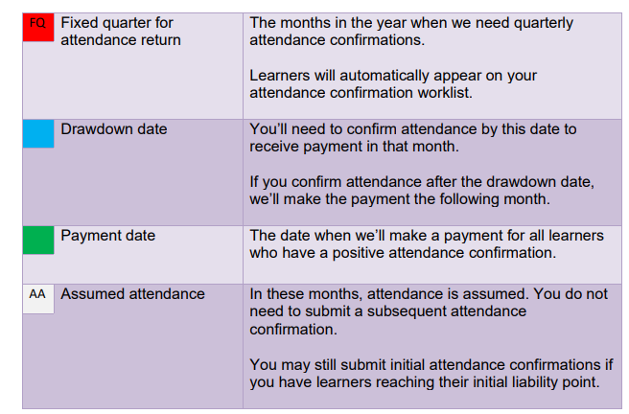

The pre-liability period is the first 14 days starting from the nominal (as opposed to actual) start date of the course—learners may withdraw from courses without cost during this period.
This is what is likely to happen for courses starting in the week beginning 8 September 2025 or later—the September instalment will be paid together with the October instalment on 15 October 2024.

